

Assignment 2 Report

CZ4042 Neural Networks

Name: He Yuhao

Matric. Number: U1722945E

Name: Li Guanlong

Matric. Number: U1722033H

**Experiments and Results**

**Part A:** **Object Recognition**

1. After configuring the convolutional neural network (CNN) properly, with mini-batch gradient descent learning with batch size of 128, the 10000 training samples are used to train the CNN.

a. The training cost and test accuracy against learning epochs is plotted, as shown in Figure 1 and Figure 2 respectively.

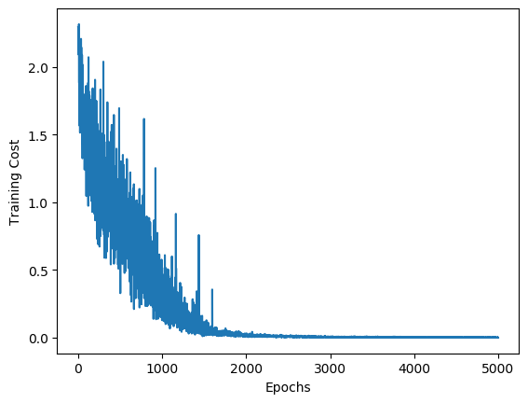 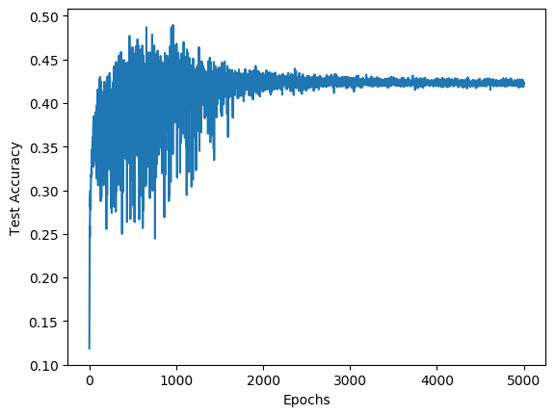

Figure 1: Training cost Figure 2: Test accuracy

b. Two test images are randomly selected, the two images and their feature maps at both convolution layers and pooling layers are shown in Figure 3, 4, 5, 6, 7, 8, 9, 10, 11,12. Figure 3 is the first image, Figure 4, 5, 6, 7 are the first image’s feature maps at the first convolution layer, the first pooling layer, the second convolution layer and the second pooling layer respectively. Figure 8 is the second image, Figure 9, 10, 11, 12 are the second image’s feature maps at the first convolution layer, the first pooling layer, the second convolution layer and the second pooling layer respectively.

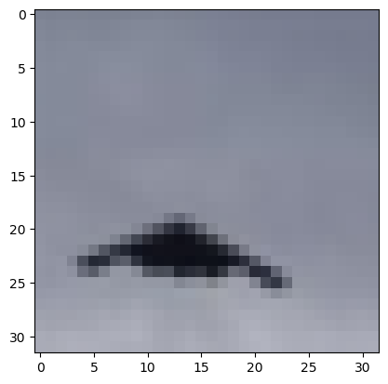

Figure 3: The first image

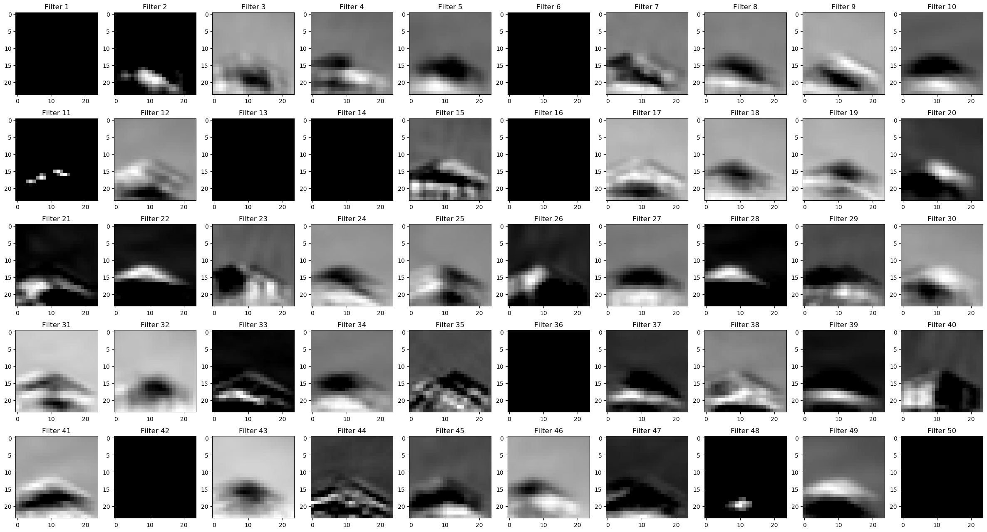

Figure 4: The first image’s feature maps at the first convolution layer

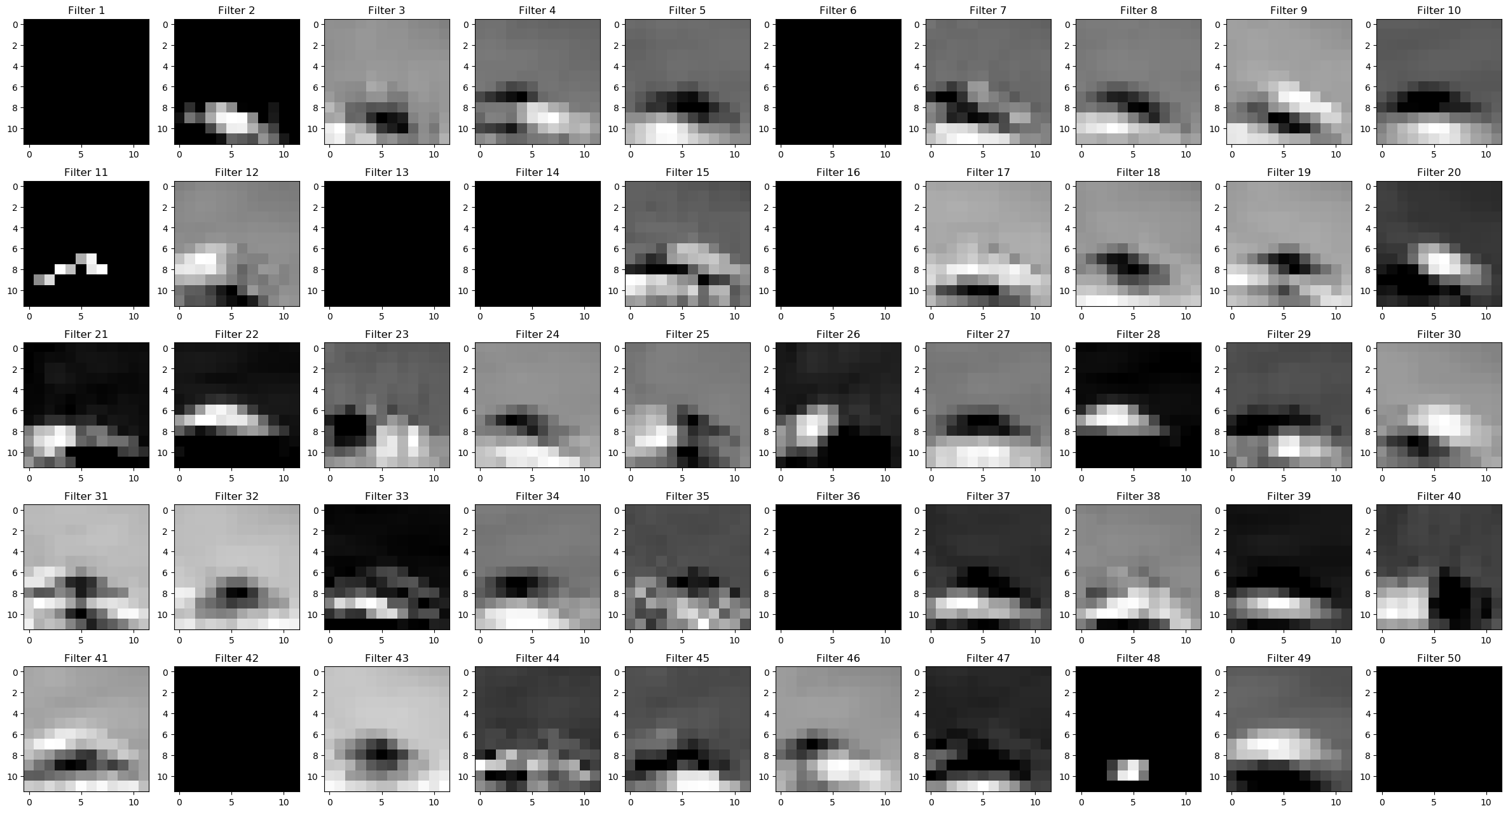

Figure 5: The first image’s feature maps at the first pooling layer

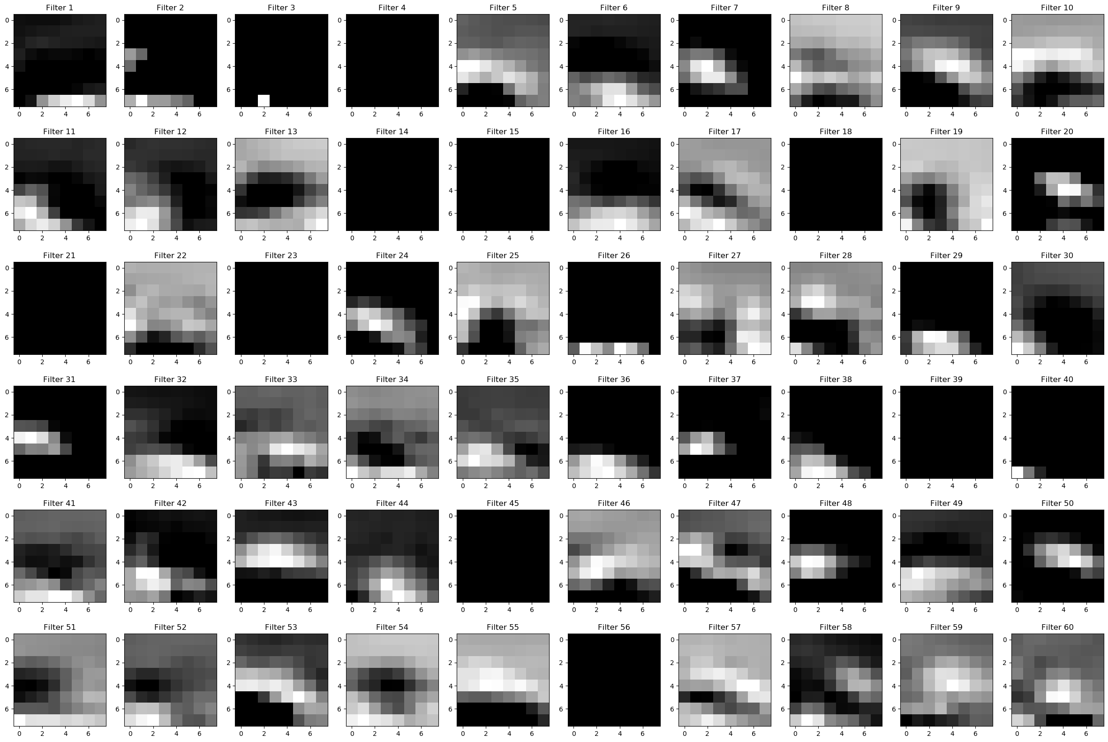

Figure 6: The first image’s feature maps at the second convolution layer

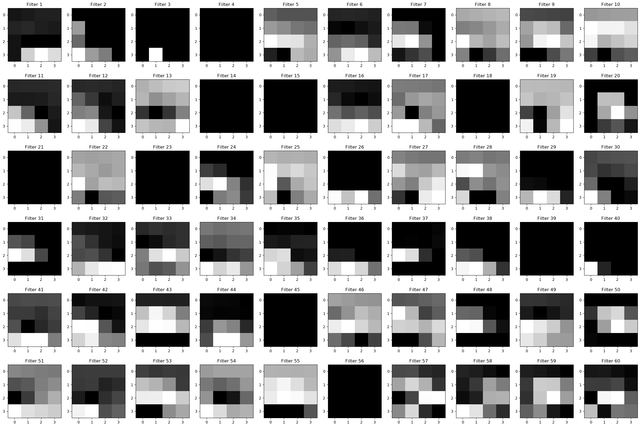

Figure 7: The first image’s feature maps at the second pooling layer

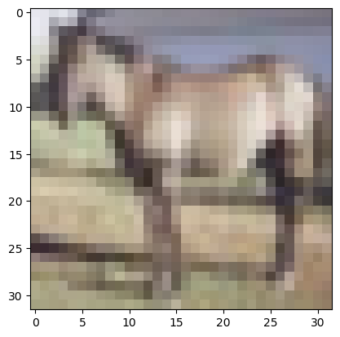

Figure 8: The second image

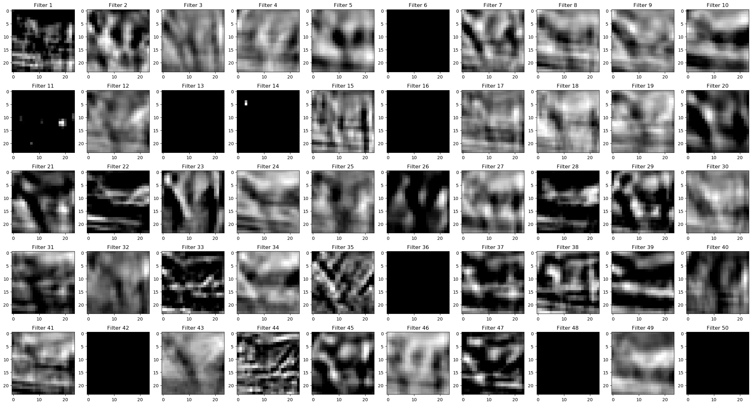

Figure 9: The second image’s feature maps at the first convolution layer

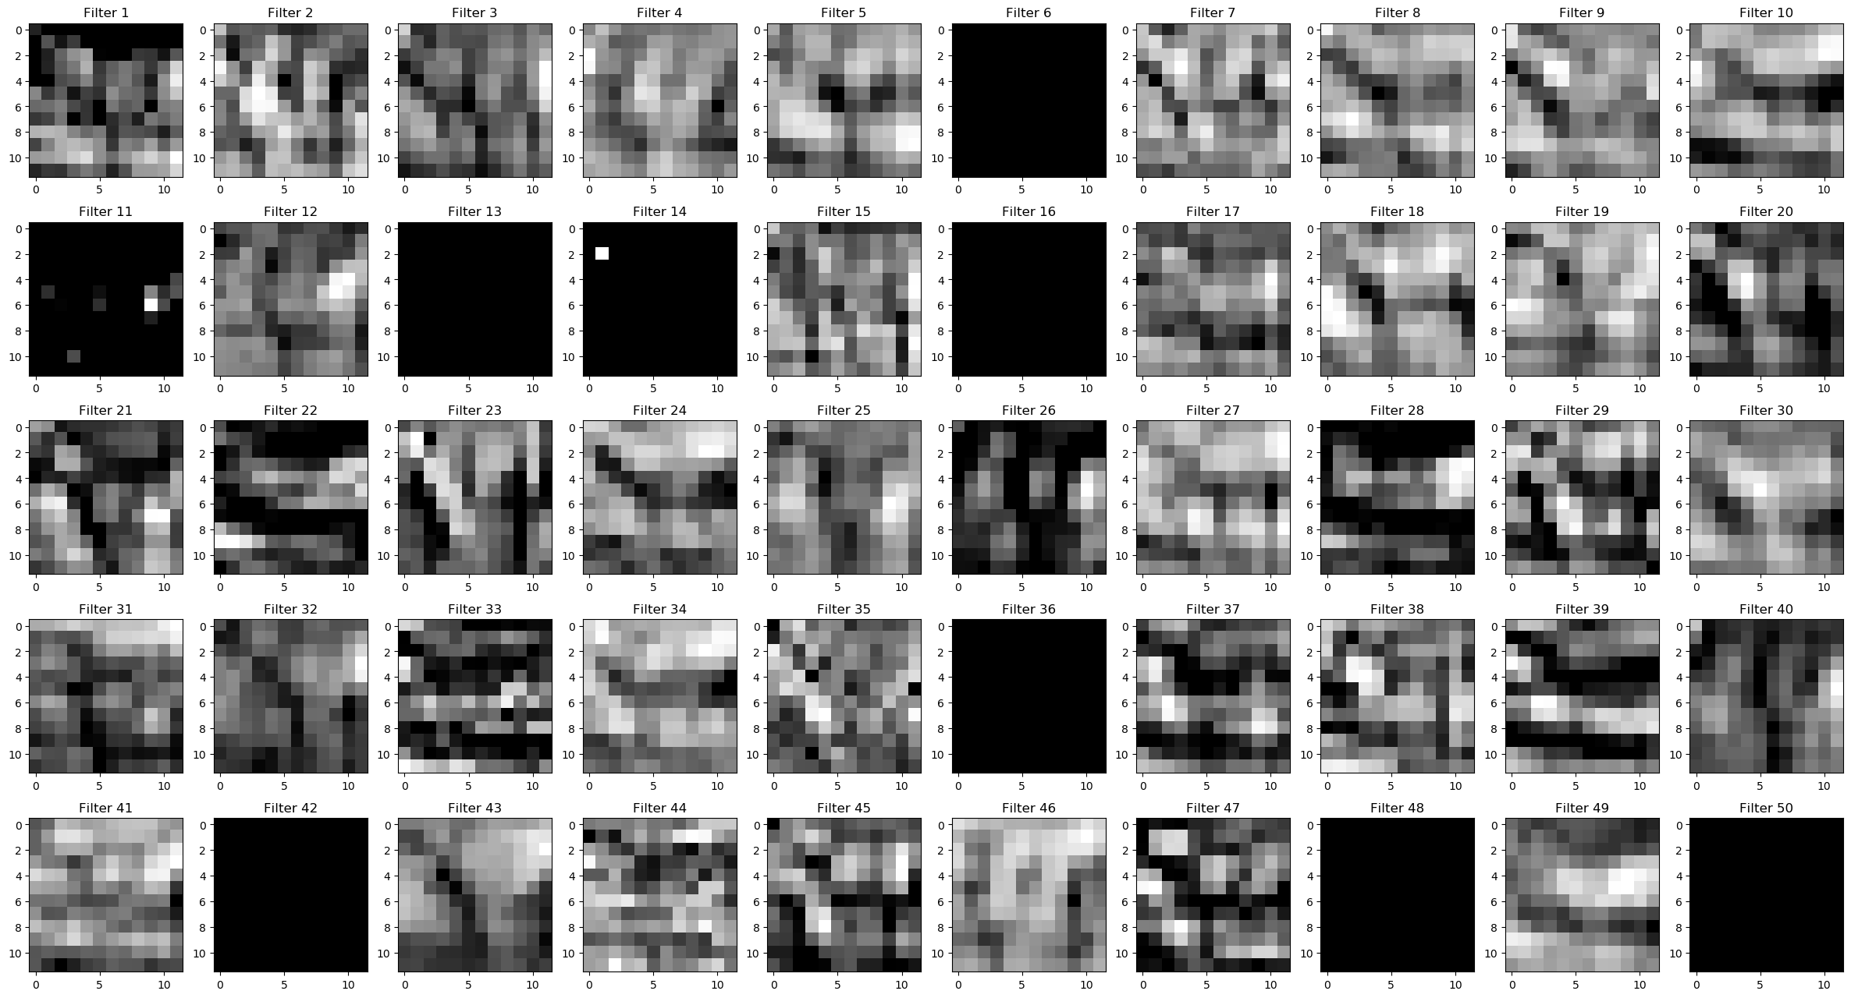

Figure 10: The second image’s feature maps at the first pooling layer

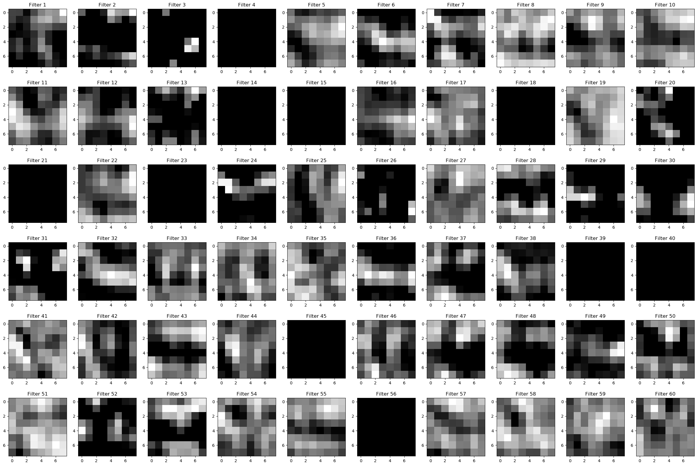

Figure 11: The second image’s feature maps at the second convolution layer

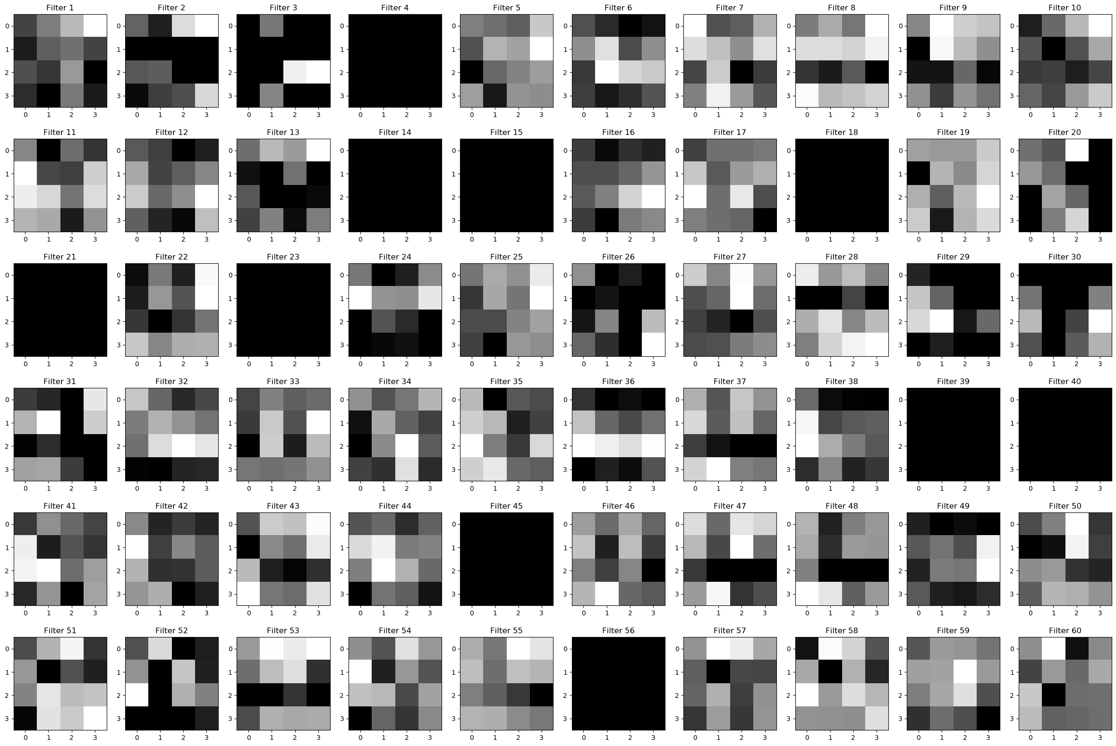

Figure 12: The second image’s feature maps at the second pooling layer

2. With a grid search, the [number of feature maps in first convolution layer, number of feature maps in second convolution layer] combinations of [40, 40], [40,50], [40, 60], [40, 70], [50, 40], [50,50], [50, 60], [50, 70], [60, 40], [60,50], [60, 60], [60, 70], [70, 40], [70,50], [70, 60], [70, 70] are examined one by one. The test accuracy against training epoch diagram for each of the combinations is shown in Figure 13, 14, 15, 16, 17, 18, 19, 20, 21, 22, 23, 24, 25, 26, 27, 28 respectively.

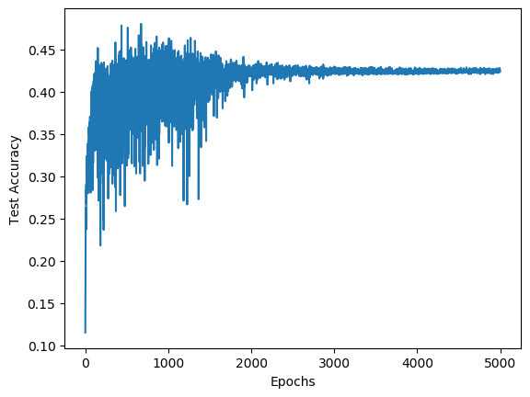 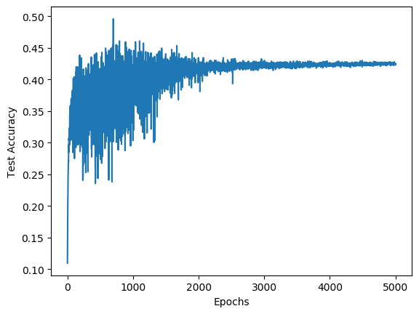

Figure 13: Test accuracy for [40, 40] Figure 14: Test accuracy for [40, 50]

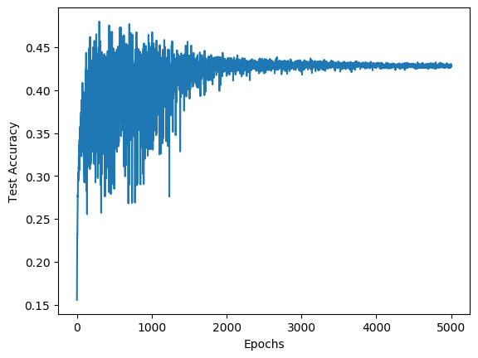 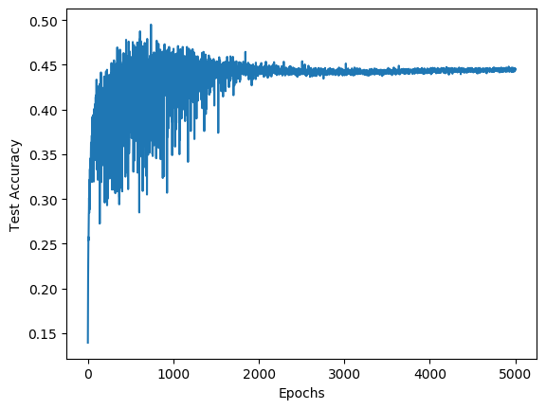

Figure 15: Test accuracy for [40, 60] Figure 16: Test accuracy for [40, 70]

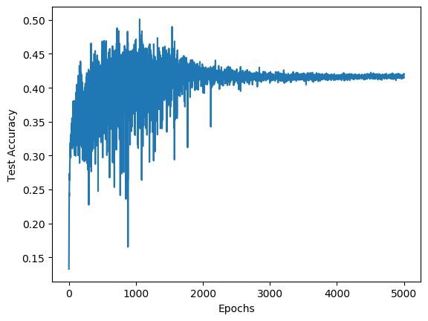 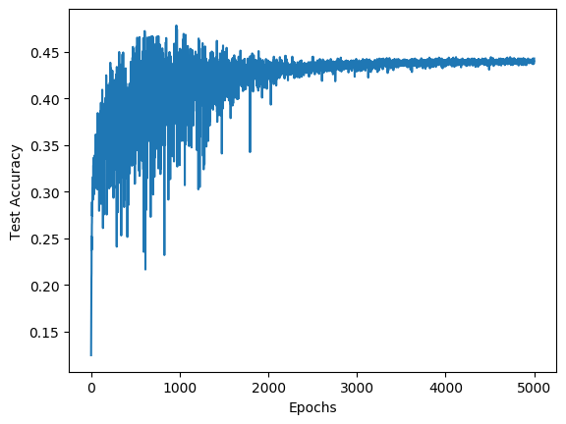

Figure 17: Test accuracy for [50, 40] Figure 18: Test accuracy for [50, 50]

 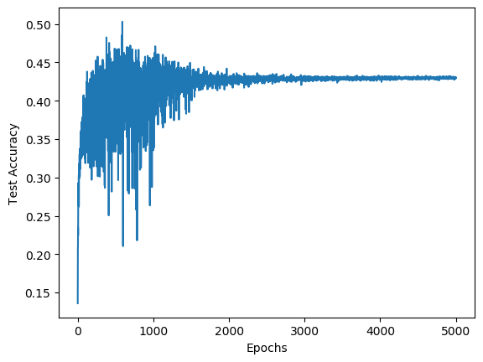

Figure 19: Test accuracy for [50, 60] Figure 20: Test accuracy for [50, 70]

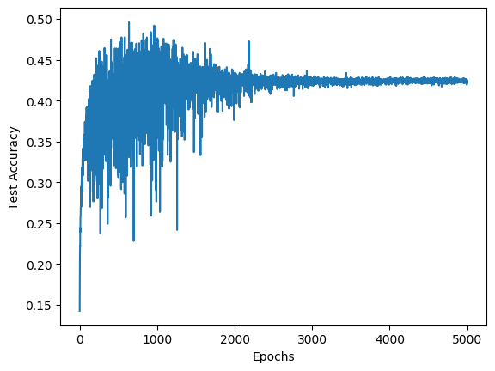 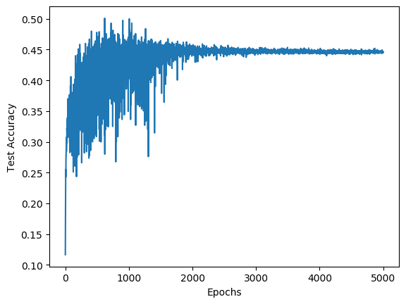

Figure 21: Test accuracy for [60, 40] Figure 22: Test accuracy for [60, 50]

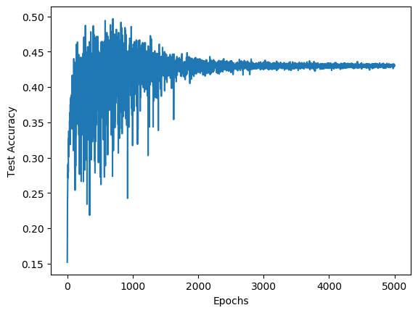 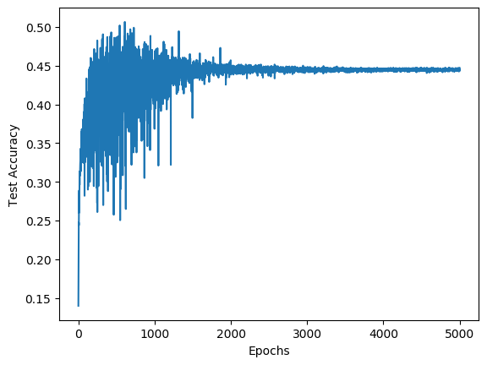

Figure 23: Test accuracy for [60, 60] Figure 24: Test accuracy for [60, 70]

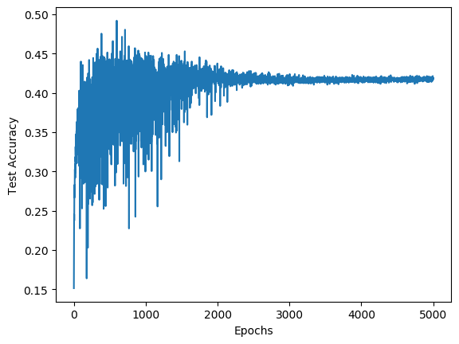 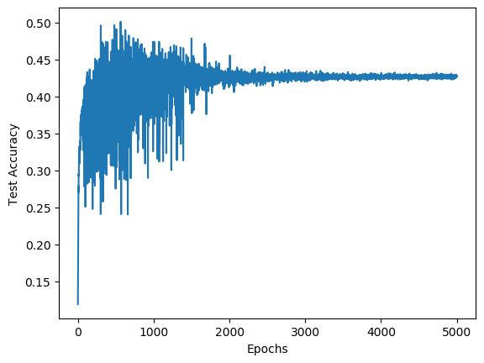

Figure 25: Test accuracy for [70, 40] Figure 26: Test accuracy for [70, 50]

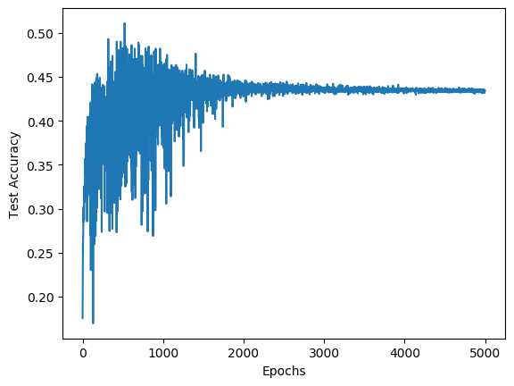 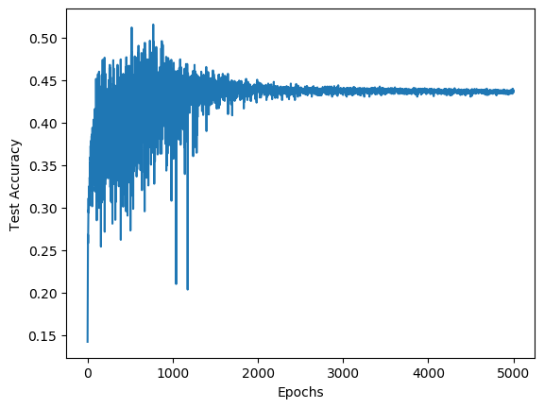

Figure 27: Test accuracy for [70, 60] Figure 28: Test accuracy for [70, 70]

From the figures above